**Email Automation**

This document will explain you how to create automation for sending emails to specified users using Excel. For our example, we will create an automation to send weekly performance reports to a list of employees in excel.

**Step 1:** Open outlook and check [**Addin**](https://docs.zappy.ai/docs/outlook-addin).

**Step 2:** Create an Excel sheet with Sender Email Address, Subject and body.

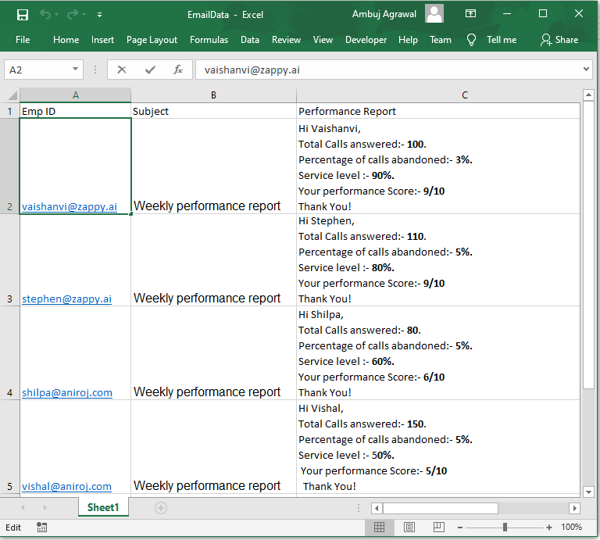

**Step 3:** Right click on Zap icon at bottom right corner of your widow and select Task Editor or double click on **Zap** icon.

**Step 4:** Open **EmailAutomation.zappy** task.

**Automation:**

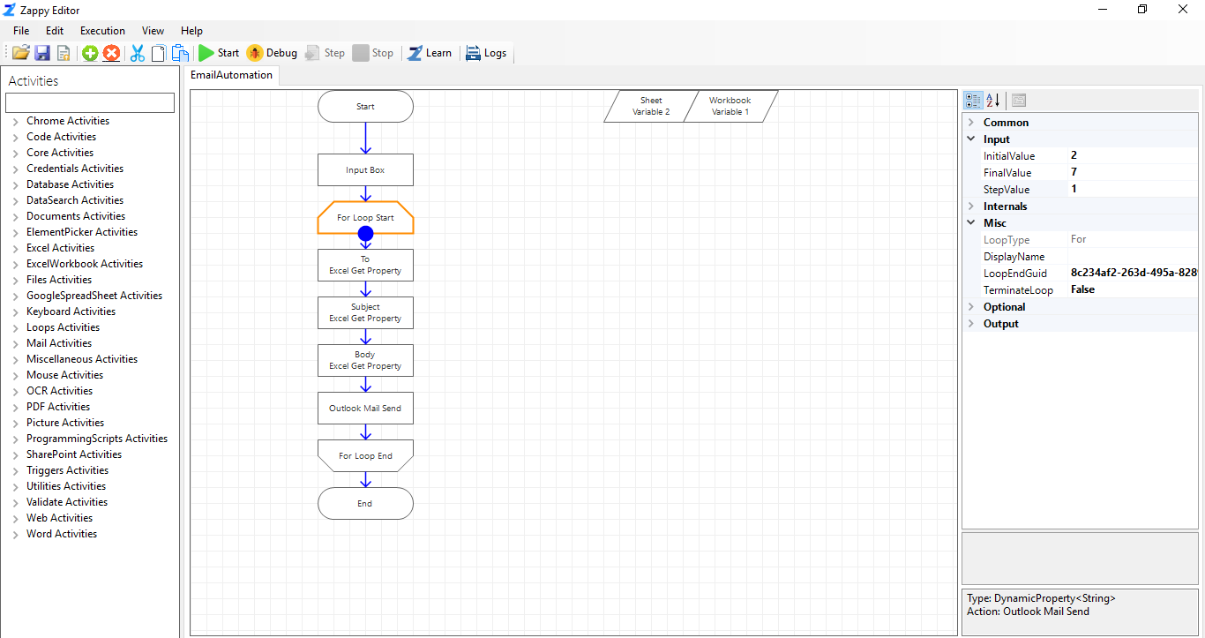

**Step 5:** Click on **For loop Start** action and enter **Intial** and **Final Value** based on your requirement. These are the starting and ending row index values of your excel sheet.

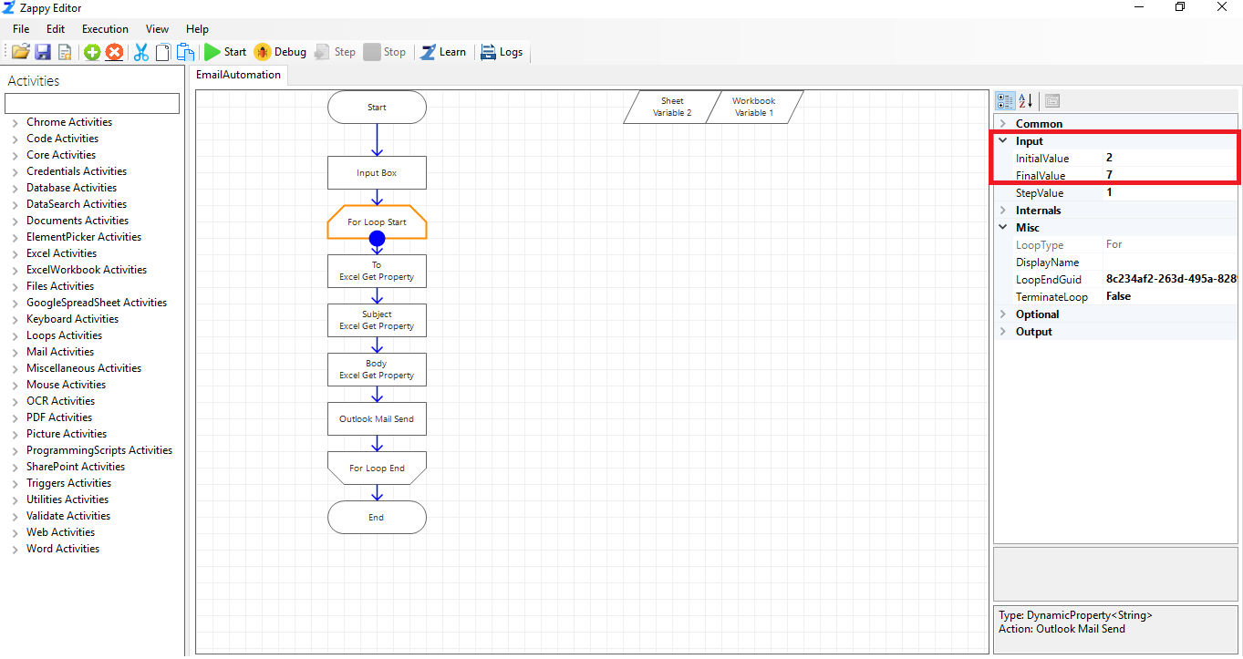

**Step 6 :** Enter your Mail Id in Input Box and click on **OK**.

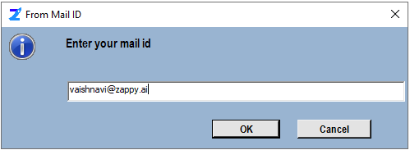

**Output:** Check your Outlook **Sent Items** to verify that all emails are sent or not.

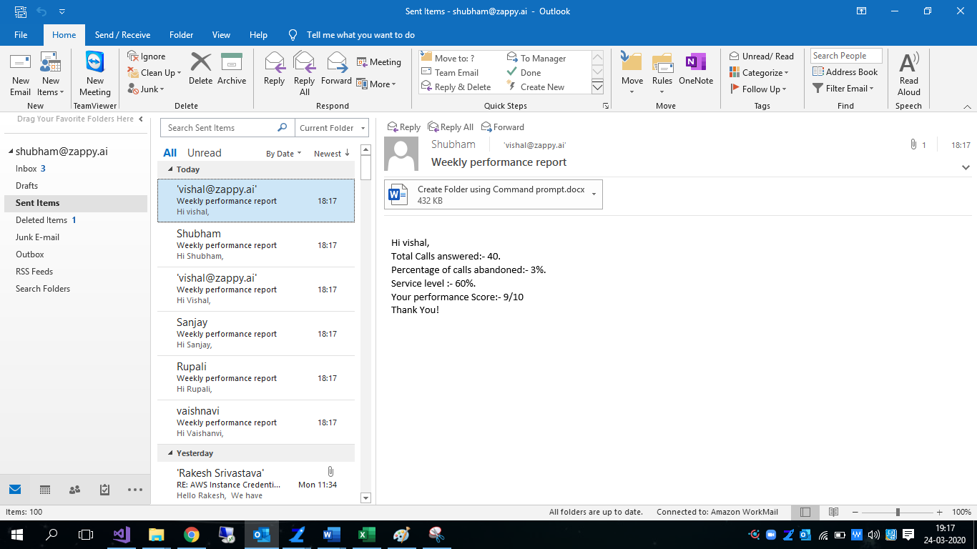

If this operation is required to be performed regularly, then we can even add a **Schedule Time Trigger** activity to saved automation in Task Editor. In the following screenshot, we demonstrate the use of **Schedule Time Trigger** to send our reports everyday at 11.00 AM. Select **Weekdays** for Repeat Days and enter the desired time of the day in 24hr format in“Trigger Fire Time”.

